**Linux Package Management system call API**

**Introduction**

Every Linux system needs to add, remove, and update software. In the past this meant downloading the source code, setting it up, compiling it, and copying files onto each system that required updating. Thankfully, modern distributions use packages, which are compressed files that bundle up an application and its dependencies (or required files), greatly simplifying the installation by making the right directories, copying the proper files into them, and creating such needed items as symbolic links.

A package manager takes care of keeping track of which files belong to which package and even downloading updates from repositories, typically a remote server sharing out the appropriate updates for a distribution. In Linux, there are many different software package management systems, but the two most popular are those from Debian and Red Hat.

**Debian Package Management**

The Debian distribution, and its derivatives such as Ubuntu and Mint, use the Debian package management system. At the heart of Debian package management are software packages that are distributed as files ending in the .deb extension.

The lowest-level tool for managing these files is the *dpkg* command. This command can be tricky for novice Linux users, so the Advanced Package Tool, *apt-get* (a front-end program to the *dpkg* tool), makes management of packages easier. Additional command line tools which serve as front-ends to *dpkg* include aptitude and GUI front-ends like Synaptic and Software Center.

**Activity 1: Install packages**

Example: install and remove *nmap* tool.

*sudo apt install nmap*

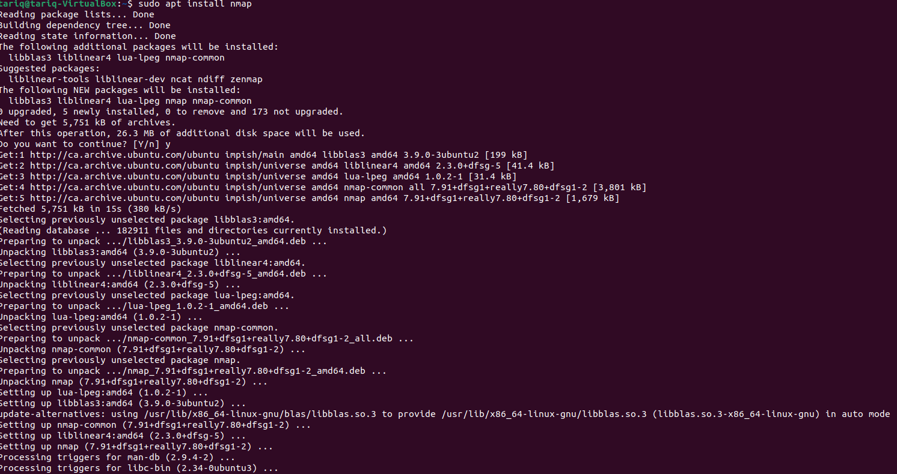

We need to be in administrator mode called in **Sudoers group** to install software.*Sudo command –* or Super User Do – grants you privileges to run sensitive tasks.

Test if *nmap* works (nmap is a network tool that scan opened ports in machines)

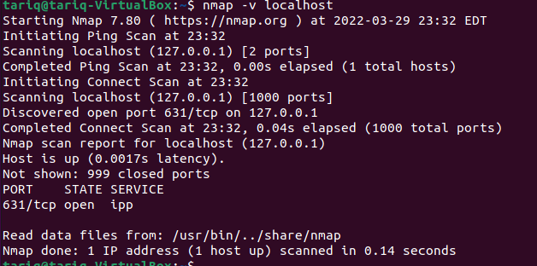

To remove the nmap tool:

*sudo apt remove nmap*

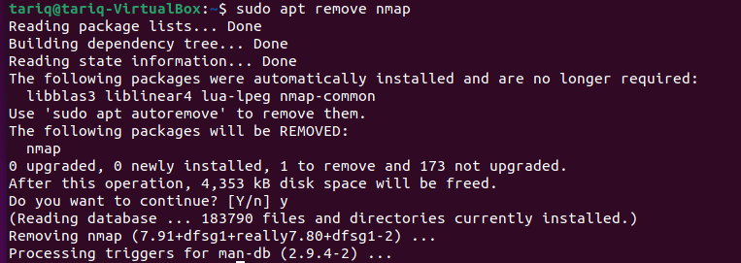

Test if the *nmap* is installed in the system:

*apt-cache policy nmap*

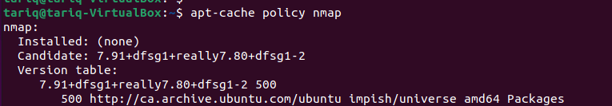

Reinstall *nmap* tool again and test it.

Using *which* command, you can validate the location where the *nmap* installed.

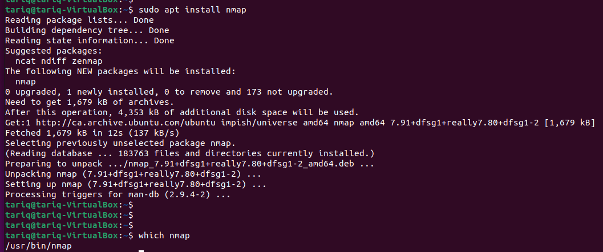

Test if the *nmap* is installed in the system again:

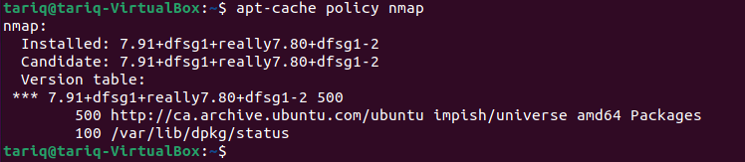

**Task1:**

What is the different between the two outputs?

**Activity2:****List installed packages**

*apt-cache policy*

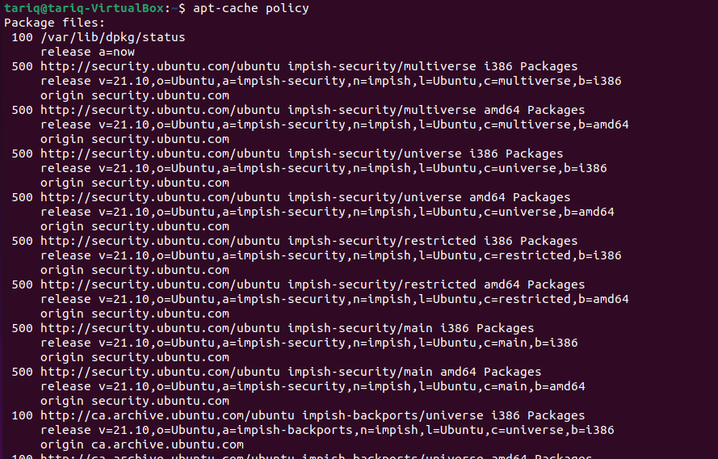

**Task2:**

Check if your system has C/C++ compiler (the famous gcc/g++), if not installed install it and show the version).

**Activity 3:** **compile and run application, find program performance with command system call**

Command to check your complier 🡺 g++ --version // to make sure that you have it

**Task4: You will write a simple program in three languages (C++, Java, Python). The program is very simple just a simple loop that find the sum for index number.**

**Example in C++,**

**Create file for each programming language for C++**

*Touch filename or nano filename // create a file*

***nano file51.cpp***

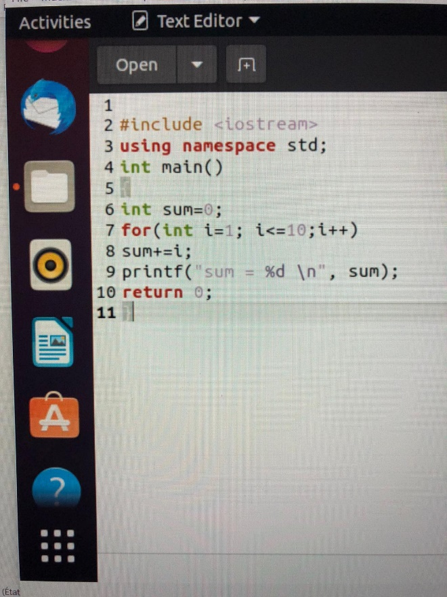

***Compile and run the code, without and with time command as following:***

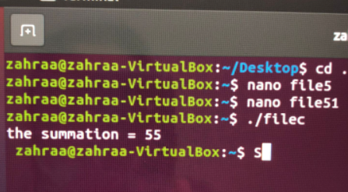

**your code must be parameterized and generic especially for variable *n* number of iteration, and passed to program via by cmd.**

**Example in Java**

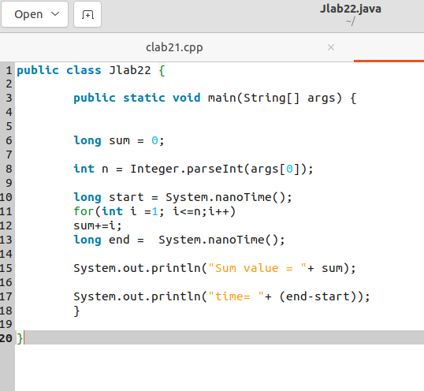

**To compile and run 🡺 install java compiler**

***sudo apt install openjdk-16-jdk-headless***

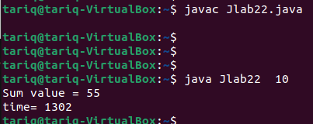

**Example python**

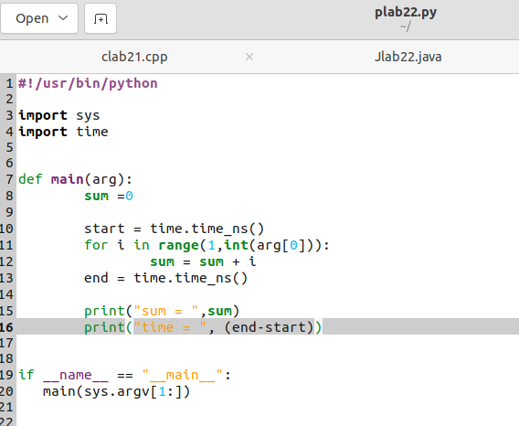

**To compile and run**

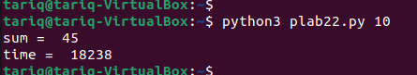

**References**

NDG Linux Essentials English Course

<https://www.netdevgroup.com/online/courses/open-source/linux-essentials#:~:text=NDG%20Linux%20Essentials%20is%20an,practice%20Linux%20command%20line%20concepts>.

<https://ubuntu.com/server/docs/package-management>

<https://help.ubuntu.com/community/InstallingSoftware?_ga=2.8929013.1538928467.1648605660-330138619.1648496262&_gac=1.89383529.1648517040.CjwKCAjwuYWSBhByEiwAKd_n_sAklvsyhlv8ZsqwMP_JNZS_pvbrgYdNn6f4_fQ7AqoOjly-C774YRoCbTEQAvD_BwE>

<https://vitux.com/how-to-use-apt-get-package-manager-on-ubuntu-command-line/>

<https://phoenixnap.com/kb/how-to-manage-packages-ubuntu-debian-apt-get>

[How To Install and Enable SSH Server on Ubuntu 20.04 – devconnected](https://devconnected.com/how-to-install-and-enable-ssh-server-on-ubuntu-20-04/)